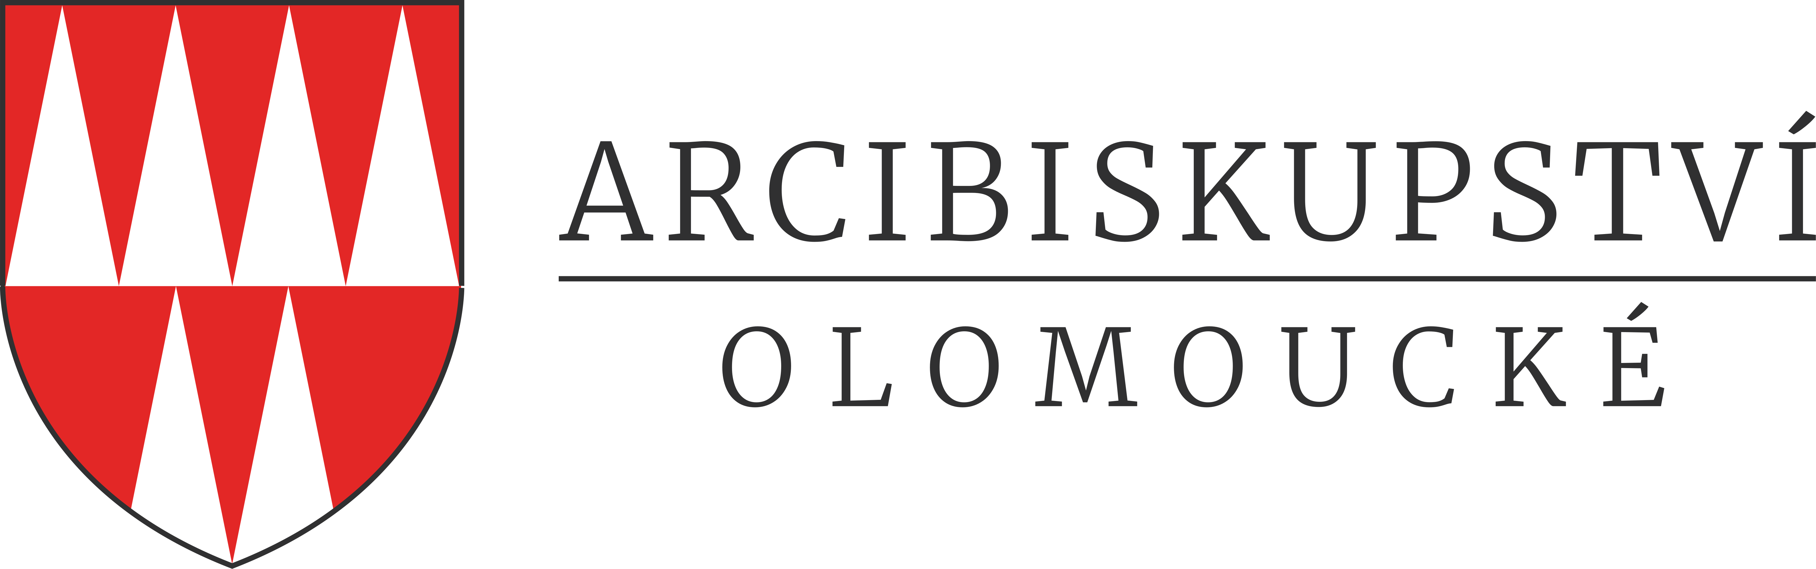
Wurmova 562/9, 779 00 Olomouc

Please fill in your name and address:

Filled by: Arcibiskupství olomoucké (Archbishopric of Olomouc)
Permission for publishing activities

Number: By: Phone No.: In Olomouc, date:

Archbishopric of Olomouc agrees that the below signed claimer will be enabled to perform (only with acceptance of the official conditions):

- Enabling of taking photo documentation
- Take-over of photo documentation already made provided by the owner/administrator
- Publishing of the required photo documentation

Sincerely,

…………….………………………………………
Vicar General of the Archbishopric of Olomouc

General conditions for the realization of publishing activities:
- This permission is valid only for the first publishing of the required photo documentation.
- The photo documentation can be published only in the extent and for the purpose set below and not without the permission of the owner/administrator and the Archbishopric of Olomouc.
- Archbishopric of Olomouc will receive 2 pcs. of the below stated publication immediately after its publishing.

Conditions for the acquisition of the photo documentation:
1. Dates of the visit in the object are necessary to set before with the owner/ administrator (in case of churches with the pastor of the appropriate parish).
2. Pictures will be taken only with a presence of a person assigned by the owner/administrator, who will set his own conditions.
3. The claimer will be identified to the owner/administrator by his/ her ID or passport.
4. Photo documentation can be taken only within this permission (It is allowed to take pictures only of the objects that are included in this permission, in case that permission is given to the architecture of the building it is not allowed to take detailed pictures of the mobiliary).
Conditions for the take-over of the photo documentation already made
1. Dates of the photo documentation take-over are necessary to set in advance with the owner of the photo documentation (Olomouc Museum of Art), who will set his own conditions.

Specific conditions:

Filled by claimant:
Name and surname/Name of the company:
Address:
Contact detail: (email, phone number)

Purpose of the publishing, including the name of the publications:

Expected term of publishing:

Character of the publication¹⁾:
- commercial
- educational, non-profit
- advertising

Edition amount:

I request¹⁾:
- Enabling of taking photo documentation
- Take-over of photo documentation already made provided by the owner/administrator

The object of the publishing activities is²⁾:
Building³⁾:
Object⁴⁾:
Assumed number of published photos:

Personal data processing information:
The Archbishopric of Olomouc shall, in accordance with Article 13 of Regulation (EU) 2016/679 of the European Parliament and of the Council on the protection of natural persons with regard to the processing of personal data and on the free movement of such data, and repealing Directive 95/46/EC ("GDPR"), inform the applicant that it will process the personal data provided by him in the position of administrator. Full information of the processing of personal data is available at https://www.ado.cz/gdpr/.
Fill in this form Permission for publishing activities and please send it by email to: pamatky@ado.cz.
__________________________________________________________________________________________
- Mark (underline).
- If the amount of lines is not sufficient, please copy them to another page
- Please specify in form: town, name of the building
- Please specify the object (example. church architecture, paintings of a concrete painter etc.).

